**Assignment : 01**

First of all we should check table of given database.

select * from Products

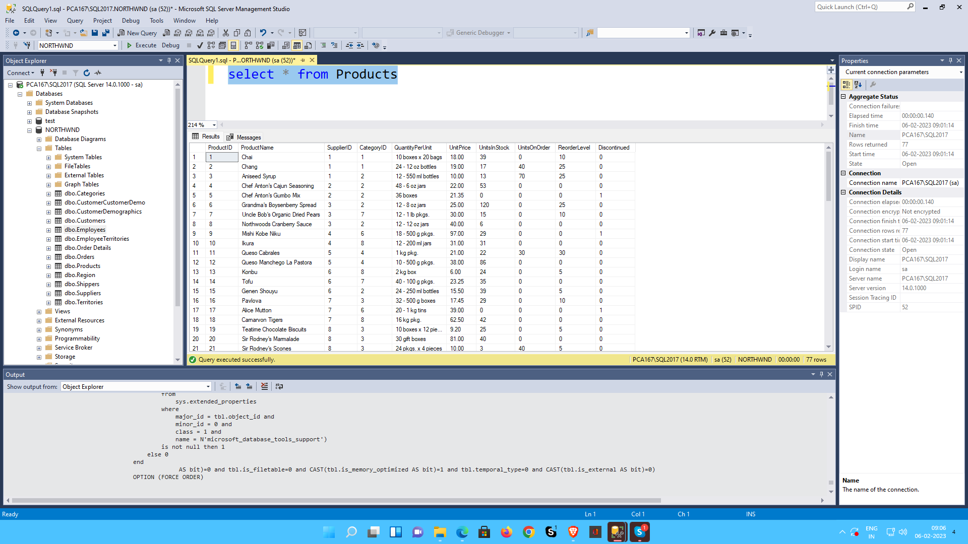

**1. Write a query to get a Product list (id, name, unit price) where current products cost less than $20.**

**select ProductID,ProductName,UnitPrice from Products**

**where UnitPrice<20;**

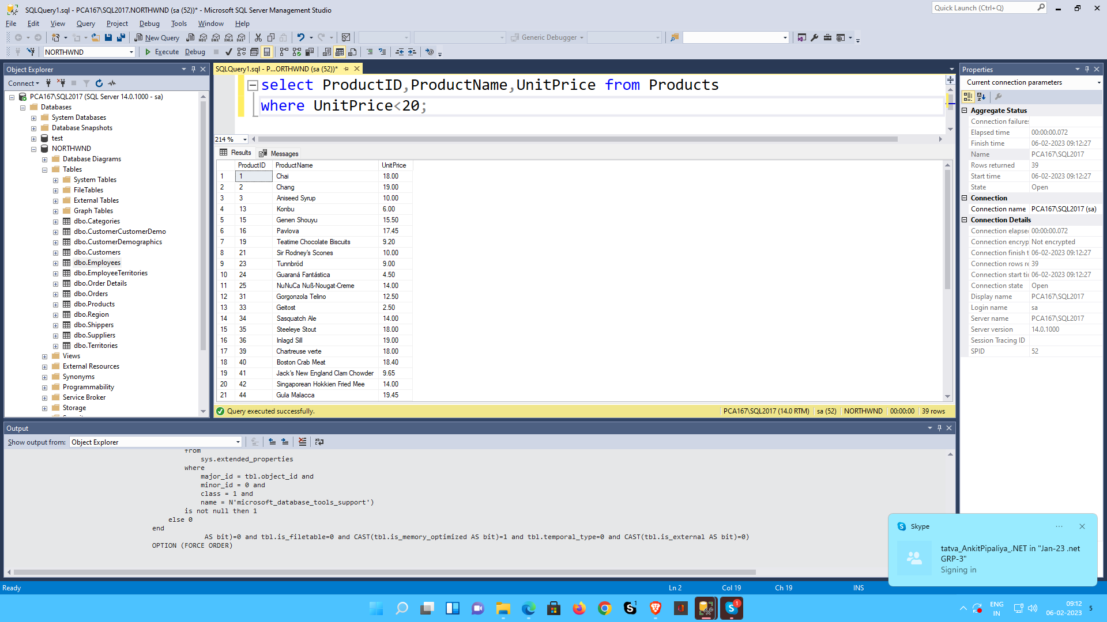

**2.Write a query to get Product list (id, name, unit price) where products cost between $15 and $25**

**select ProductID,ProductName,UnitPrice from Products where UnitPrice between 15 and 25**

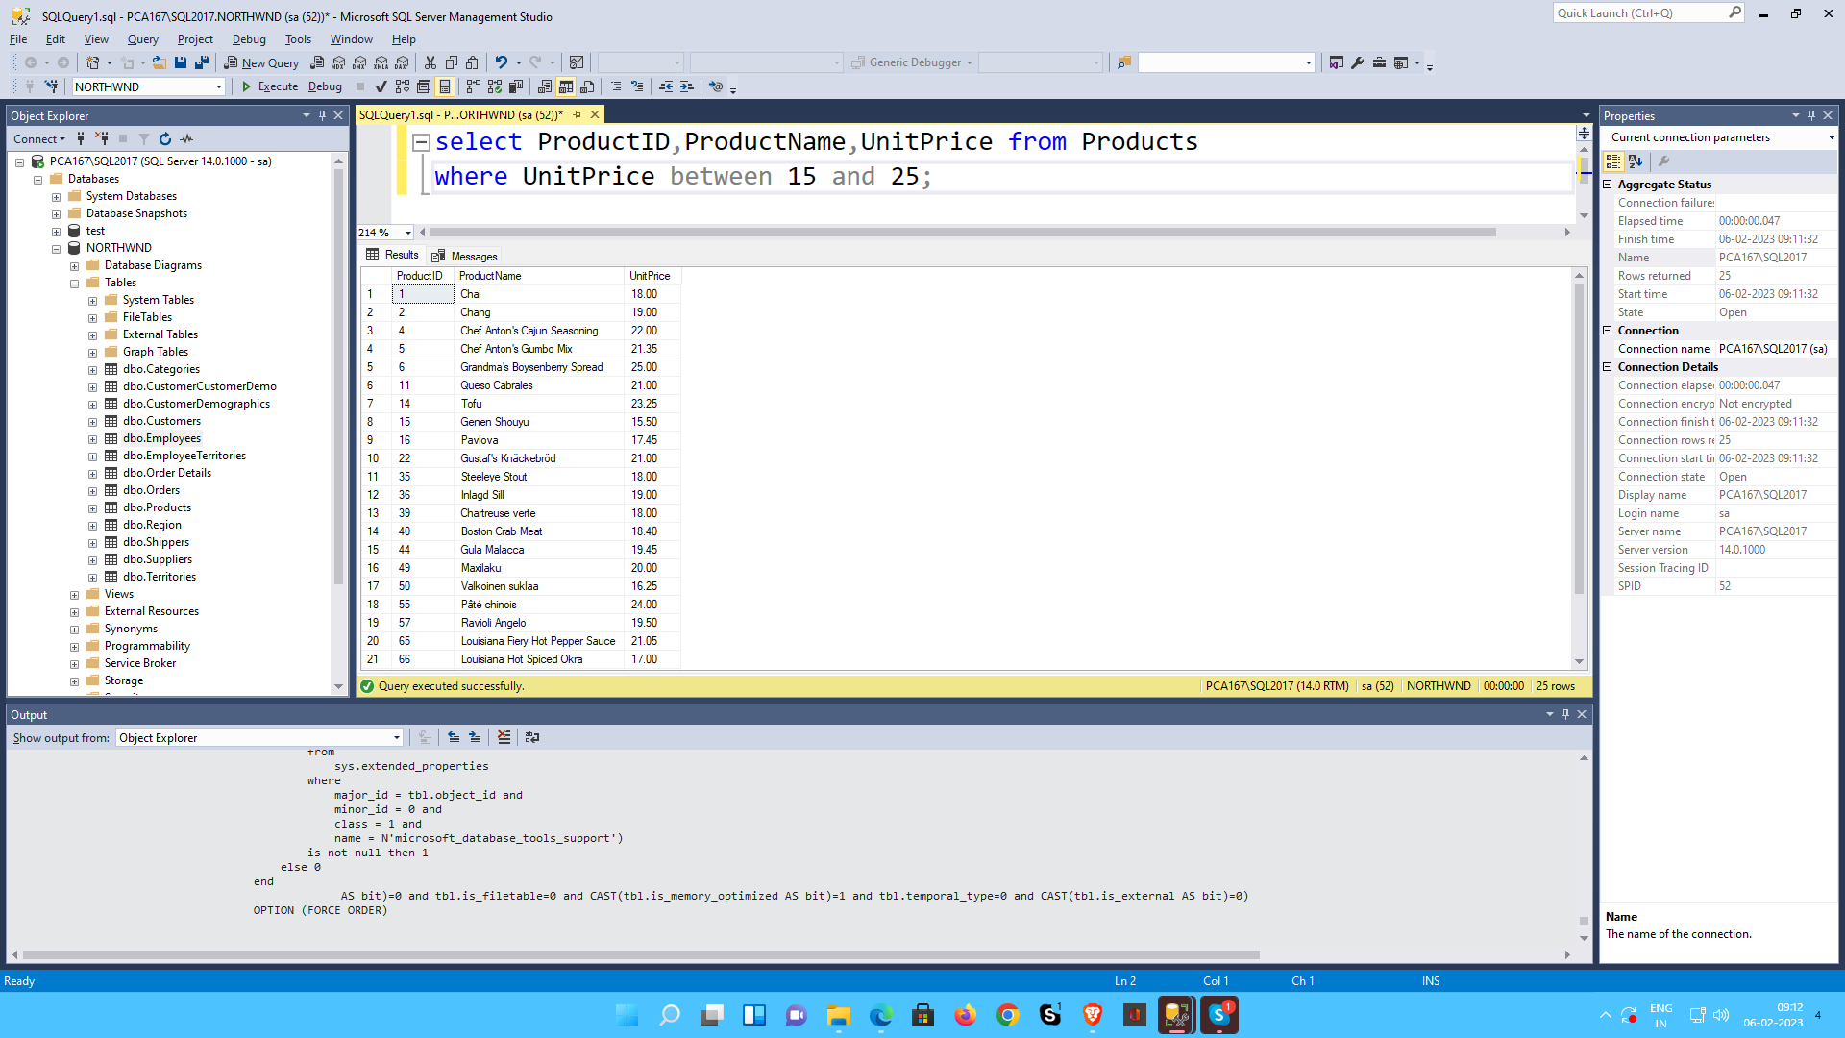

**3.Write a query to get Product list (name, unit price) of above average price.**

**select ProductName,UnitPrice from Products p**

**where UnitPrice > (select avg(UnitPrice) from Products)**

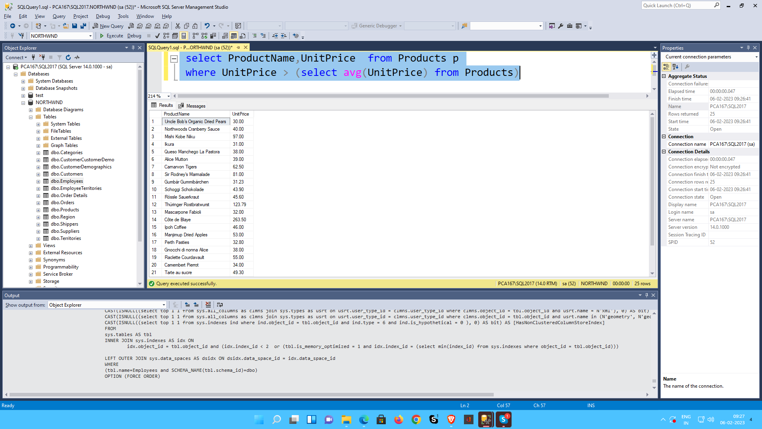

**4.. Write a query to get Product list (name, unit price) of ten most expensive products**

**select TOP(10) ProductName,UnitPrice from Products p**

**order by UnitPrice DESC;**

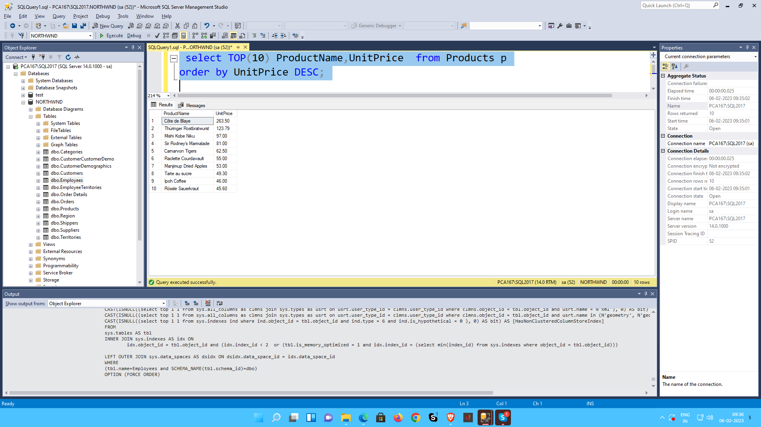

**5.Write a query to count current and discontinued products**

**select COUNT(ProductID) FROM Products P WHERE (P.Discontinued = 0 )**

**select COUNT(ProductID) FROM Products P WHERE (P.Discontinued = 1 )**

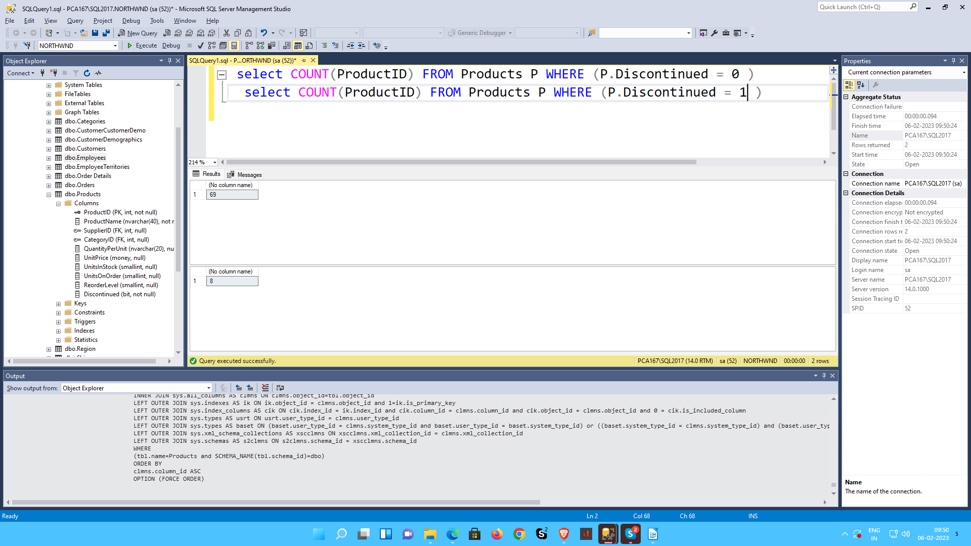

**6.Write a query to get Product list (name, units on order , units in stock) of stock is less than the quantity on order**

**select ProductName,UnitsOnOrder,UnitsInStock from Products**

**where UnitsInStock<UnitsOnOrder**

